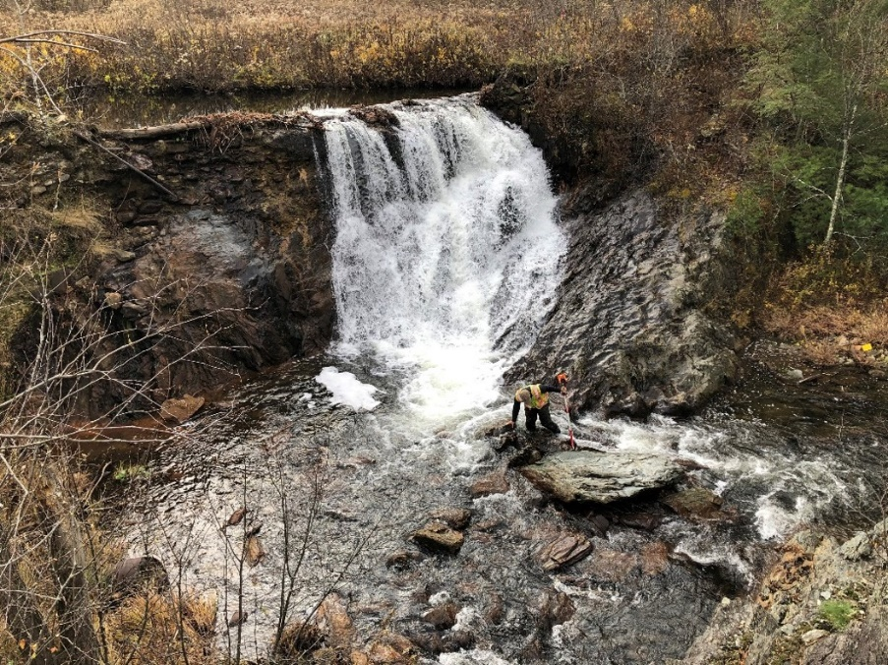
IN 2019, the Franklin County Natural Resources Conservation District (NRCD) retained Stone to perform a dam removal feasibility assessment of Johnsons Mill Dam, located on Bogue Branch in Bakersfield, Vermont. Once used to power a nearby sawmill, the obsolete dam caused adverse impacts on the habitat and migration of brook trout, a Species of Greatest Conservation Need in Vermont watersheds. Acting on behalf of a private landowner, the Franklin County NRCD secured funding from the Vermont Fish and Wildlife Department to remove the dam, restore the Bogue Branch to a free-flowing state, and improve water quality, flood resilience, and aquatic organism passage (AOP).
Looking southeast at the Johnsons Mill Dam along Bogue Branch in Bakersfield, VT, in 2019.
Services / Expertise
Aquatic Organism Passage Assessment
Dam Removal Assessment
Preliminary Design (30%) Plans
Final Design (100%) Plans
Stream Restoration and Floodplain Protection
Sediment Analysis, Characterization, and Management
Topographic Survey and Geomorphic Assessment
Hydraulic & Hydrologic Modeling
Infrastructure Stability Analysis
Channel Restoration Plan
Erosion Prevention & Sediment Control Plan
Stakeholder Collaboration & Stewardship
Construction Management & Oversight
Markets
Watershed Protection Organizations
Local and Regional Government
Site/Property Owners
Project Location
Bakersfield, Vermont
Date Completed
2019-2021
Project Owner
Franklin County Natural Resources Conservation District
Client Reference
Brodie Haenke, Conservation Specialist, Franklin County Conservation District
NRCS Field Office
50 South Main St. #20
St. Albans, VT 05478
(802) 528-4180
broderick.haenke@vt.nacdnet.net
Project ID#
19-093
Project Manager
Gabe Bolin, PE
(603) 809-6101
gbolin@stone-env.com
Project Team
Peter Lazorchak, PE, LEED AP
Meghan Arpino
Branden Martin, PE
The initial scope of work was divided into two phases: a dam removal AOP assessment, followed by a more comprehensive dam removal assessment and the development of preliminary engineering and design plans for removal.
As part of the Phase 1 AOP assessment, Stone completed surveying and sediment probing to determine if removing the dam structure was likely to improve passage for brook trout (i.e. presence of natural bedrock barrier).This phase also included a limited geomorphic assessment of the reach upstream of the dam impoundment, where Stone staff collected bankfull width and depth measurements, characterized the impoundment nature and extent upstream of the dam and recorded streambed sediment and bank observations. Overall, these preliminary assessments indicated that AOP was likely following dam removal.
Stone began Phase 2 of the project with topographic surveys and the initiation of preliminary designs in early fall of 2019. However, the Halloween storm of 2019 brought over 4.5 inches of rain in less than 24 hours, equivalent to a 100-year storm event, resulting in extreme floodwaters that overtopped the dam, and a breach of the dam at a vulnerable location. A set of old stop logs that were stacked and set behind the dam at one time to control the impounded water surface elevation gave way, releasing enough water to break off a significant portion of the concrete dam, and cause the failure and obliteration of a cobble and masonry channel wall just downstream of the dam. Following consultation with the client, the project was put on hold until a plan for moving forward was developed. In November 2019, the District received a grant for $125,000 from the Lake Champlain Basin Program to remove the dam.
The second phase resumed with a resurvey of the site to assess impacts from the storm. Survey data indicated downcutting of the former impoundment and upstream channel ranged from 0.5 to 4.5 feet from original grade, leaving near-vertical banks throughout the project area. Working with the client, Stone developed an adapted conceptual design that included an assessment of dam removal that offered bank stabilization upstream of the dam. To inform the conceptual engineering design, Stone determined the volume of impounded sediment remaining and developed a one-dimensional hydraulic model of the existing and proposed conditions at the site to assess dam removal scenarios. Final deliverables included 30% design plans, costs and a final report summarizing the design efforts.
The NRCD retained Stone in 2020 to complete Phase 3 of the project to develop 100% engineering design plans, secure all applicable permits, and provide construction oversight and support necessary for the removal of Johnsons Mill Dam. To inform 100% designs and assess conditions following the partial dam breach, Stone completed additional topographic surveying and analysis of ground penetrating radar (GPR) data collected by TCE, to determine depth of bedrock in the vicinity of the dam. Final designs included a valley cross section designed to anticipate the development of floodplains at lower elevations and adjustment for the pilot channel. Stone assisted with selection of a contractor in the spring of 2021 and provided construction oversight of dam removal and bank stabilizations in August 2021. Construction included dam removal, achievement of full AOP, and regrading of upstream banks to stable slopes, which were planted with native willows obtained onsite.
In spring 2022, the NRCD retained Stone to perform long-term monitoring of channel adjustments and vegetation patterns over a four-year period. Starting in summer 2022 and during each monitoring year through 2025, Stone will collect longitudinal and cross section survey data, bed material distribution via pebble counts, recruitment of large wood in the channel, and distribution, survival, and success of planted willows. Lateral bank adjustment and other details will be captured via seasonal drone aerial imagery (16 total flights), and sediment volume calculations will be performed using survey data. Plots of monitored longitudinal profile data versus design phase profiles will inform vertical adjustment patterns. This is one of the first dam removal long-term monitoring programs in the state.

